PROJECT PROPOSAL

ON

Library Management System

Guided By: Created By:
Mr. Anuj kumar Anshika Soni
Khushi Krishna
Kanika Chaudhary

AF I’D:
AF04991159
AF04991215
AF04971772

Batch Code:
ANP-D2405

Table Of Contents
Index
- Title of the Project…………………………….
- Introduction……………………………………
- Objective
- Project Category
- Analysis
  - Modules and Description
  - Database Design
  - ER Diagram
  - Data Flow Diagram
- Complete Structure
  - Process Logical Diagram
- Platform Used
  - Hardware Requirement
  - Software Requirement
- Future Scope
- Bibliography

PROJECT TITLE:
Library Management System (Terminal-Based)
Using Java, JDBC, MySQL

INTRODUCTION

Libraries are immensely important in supplying knowledge resources among students, teachers, and readers. Conventionally, maintaining a library involves manually keeping a record of books in stock, member records, and tracking of issued and returned books. These manual systems are time-consuming, full of human errors, and difficult to manage as the number of books and users grows.

To overcome these limitations, a library management system is introduced to computerize the entire operations of the library. This project focuses on developing a terminal-based application using Java, JDBC, and MySQL, which ensures efficient management of library resources while maintaining data accuracy and security.

OBJECTIVE:

- The automation of library operations, including the management of books, members, and transactions.

- To reduce paperwork and avoid manual errors in keeping records.

- To store all the information in a secure and well-organized database.

- This will ensure fast searching and retrieval of records of books and members.

- Arranging books for easier access and management.

- To systematically track the movement of books-issued and returned-to understand their availability status.

- This aims to provide a simple interface so admins can easily operate the system.

PROJECT CATEGORY:

- This project belongs to the Database Management System category.
- It is a terminal based software application.
- Core Java is used as the primary programming language.
- Java Database Connectivity (JDBC) is used to connect database with java.
- MySQL is used as the relational database management system.
- The system demonstrate CRUD operations (i.e. create, retrieve, update and delete operations).

ANALYSIS

LIBRARY MANAGEMENT SYSTEM: MODULES
- Admin Management
- Member Management
- Category Management
- Book Management
- Issue and Return Management

Module 1: Admin Management
1.1– Admin Login
1.2 – Admin Profile Update
1.3 – View System Overview / Dashboard

Module 2: Member Management

2.1 – Member Registration
2.2 – Member Update
2.3 – Member List
2.4 – Member Details / Profile
2.5 – Member Delete

Module 3: Category Management
3.1 – Add Category
3.2 – Update Category
3.3 – Category List
3.4 – Category Delete

Module 4: Book Management
4.1 – Add New Book
4.2 – Update Book Details
4.3 – Book List
4.4 – Book Details / View Book
4.5 – Delete Book

Module 5: Issue and Return Management
5.1 – Issue Book
5.2 – Return Book
5.3 – Issue List
5.4 – Return List
5.5 – Fine Calculation (If applicable)
5.6 – Due Date Tracking

DATABASE DESIGN

Table 1: Admin

Fields | datatype | properties
admin_id | int | primary key
username | varchar(50) | not null
password | varchar(50) | not null
name | varchar(100) | not null

Table 2: Member

fields | datatype | properties
member_id | int | primary key
name | varchar(100) | not null
email | varchar(100) | not null
phone | varchar(20) | not null
address | varchar(300) | not null

Table 3: Category

fields | datatype | properties
category_id | int | primary key
category_name | varchar(100) | not null

Table 4: Books

fields | datatype | properties
book_id | int | primary key
title | varchar(200) | not null
author | varchar(150) | not null
publisher | varchar(150) | not null
category_id | int | not null, foreign key

Table 5: Issue_Return

fields | datatype | properties
transaction_id | int | primary key
book_id | int | not null, foreign key
member_id | int | not null, foreign key
issue_date | date | not null
return_date | date | null
status | varchar(20) | not null

Relationship:
Books – Category:
One Category can have many Books.
Issue_Return – Books & Members:
Multiple issue-return records can belong to one book or one member.

Table 6: Category_Books_Relation

(One Category → Many Books)
fields | datatype | properties
category_id | int | primary key (Category table)
book_id | int | foreign key (Books table)

Table 7: Member_Transaction_Relation

(One Member → Many Transactions)

fields | datatype | properties
member_id | int | primary key (Member table)
transaction_id | int | foreign key (Issue_Return table)

Table 8: Book_Transaction_Relation

(One Book → Many Transactions)
fields | datatype | properties
book_id | int | primary key (Books table)
transaction_id | int | foreign key (Issue_Return table)

ENTITY RELATIONSHIP DIAGRAM

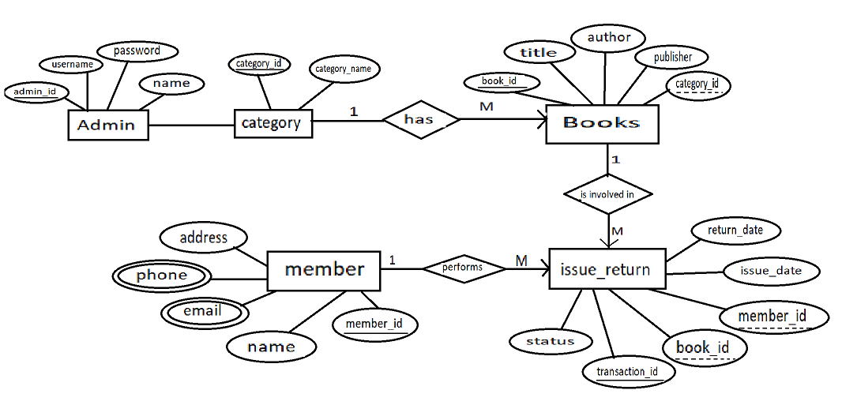

DATA FLOW DIAGRAM

ZERO LEVEL DFD

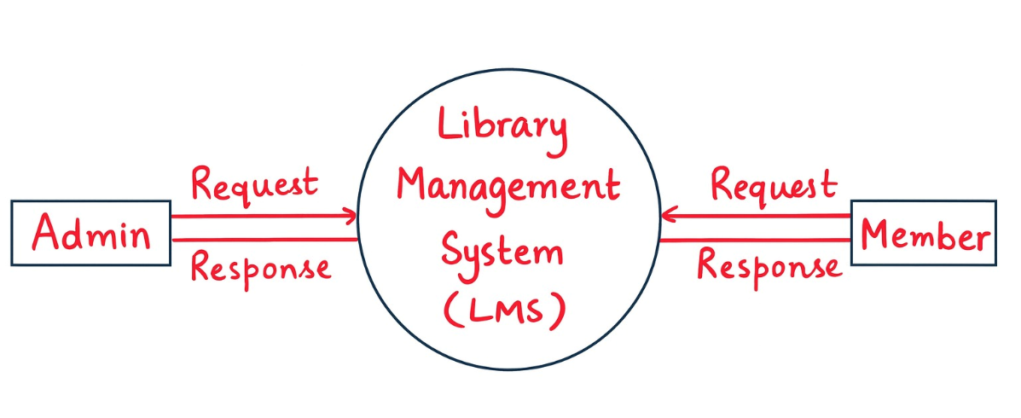

ONE LEVEL DFD
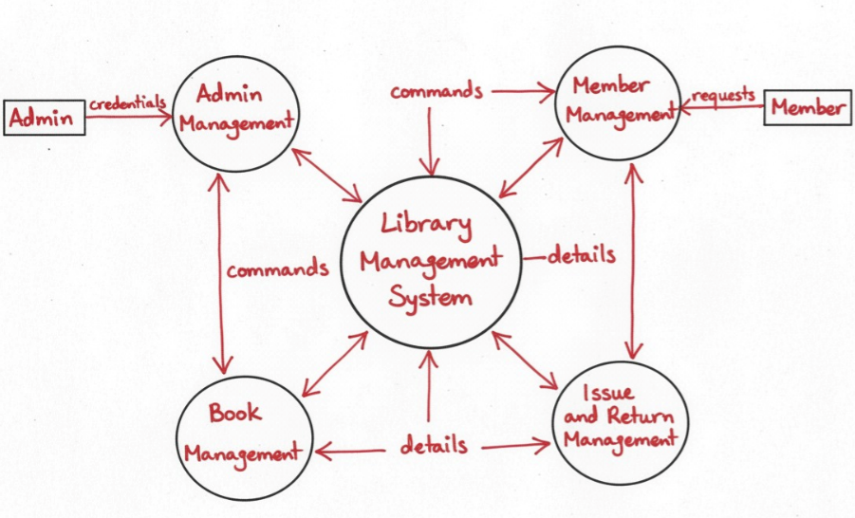

TWO LEVEL DFD

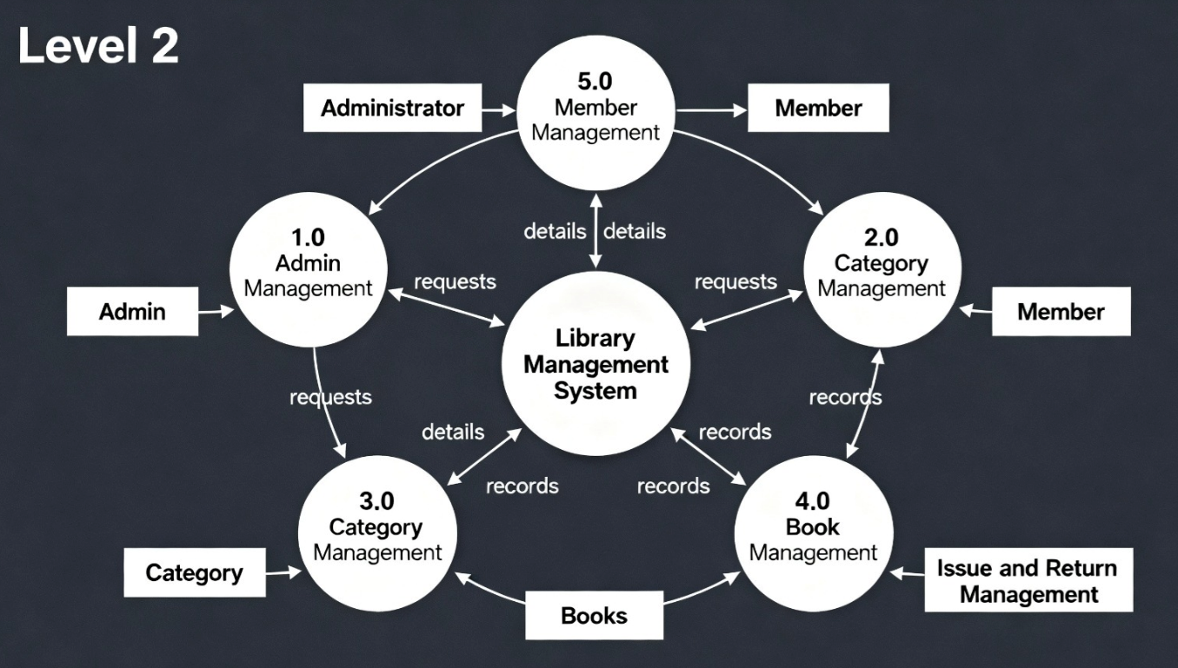

PROCESS LOGICAL DIAGRAM

START
│
▼
User Opens Library System
│
▼
Select Operation:
1. Add Member
2. Add Category
3. Add Book
4. Issue Book
5. Return Book
6. View Lists
|
┌──────────────────────────────────┼───────────────────────────────────┐
│ │ │
▼ ▼ ▼

Add Member Add Category Add Book
(Name, Email, Phone, Address) (Category Name) (Title, Author, Publisher, Category)
│ │ │
▼ ▼ ▼
Store Member Data Store Category Data Store Book Data
in Database in Database in Database
│ │ │
└──────────────────────────────────┼───────────────────────────────────┘
│
▼
┌─────────────────┐
│ Issue Book │
│ (Book + Member) │
└─────────────────┘
│
▼
Store Issue Entry in Database
│
▼
┌─────────────────┐
│ Return Book │
│ (Return Date + │
│ Status Update) │
└─────────────────┘
│
▼
Update Issue_Return in Database
│
▼
┌─────────────────┐
│ View Lists │
│ (Books, Members, │
│ Issues, Returns) │
└─────────────────┘
│
▼
Loop Back / Exit
│
▼
END

PLATFORM USED

a) Hardware Requirements
- Processor: Intel i3 or higher
- RAM: Minimum 4GB
- Hard Disk: 500MB free space
- Operating System: Windows/Linux/Mac

b) Software Requirements
- JDK 8 or above
- MySQL Server
- IDE: Eclipse / IntelliJ IDEA / NetBeans
- JDBC Driver
- OS: Windows 10/11

FUTURE SCOPE
• Adding a Graphical User Interface (GUI) for better user experience.
• Implementing online access for remote library users.
• Adding fine management for overdue books.
• Generating detailed reports with analytics for library usage.
• Integrating barcode or QR code scanning for books.

BIBLIOGRAPHY

- Oracle Java Documentation
- MySQL Official Documentation
- JDBC API Guide
- Reference books on DBMS and Java Programming
- Online educational resources (GeeksforGeeks, TutorialsPoint, JavaTPoint)

